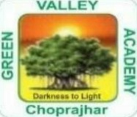
CHOPRAJHAR
GREEN VALLEY ACADEMY
CLASS XI TO XII
SCIENCE
SL. NO. | SUBJECT | NAME OF THE BOOK | NAME OF THE  PUBLISHIG HOUSE
1 | ENGLISH
2 | PHYSICS | NCERT  CLASS XI TO XII
3 | CHEMISTRY | NCERT  CLASS XI TO XII
4 | BIOLOGY | NCERT  CLASS XI TO XII
5 | COMPUTER  SCIENCE | NCERT  CLASS XI TO XII
6 | IP | NCERT  CLASS XI TO XII

