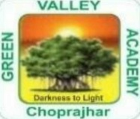
CHOPRAJHAR
GREEN VALLEY ACADEMY
CLASS XI TO XII
HUMANITIES
SL. NO. | SUBJECT | NAME OF THE BOOK | NAME OF THE  PUBLISHIG HOUSE
1 | ENGLISH
2 | HISTORY | NCERT  CLASS XI TO XII
3 | GEOGRAPHY | NCERT  CLASS XI TO XII
4 | POLITICAL  SCIENCE | NCERT  CLASS XI TO XII
5 | IP | NCERT  CLASS XI TO XII

